**Defect Report:**

|  |  |  |
| --- | --- | --- |
| **Defect ID** | **Defect Description** | **Priority** |
| DEF_001 | No products are displayed for any search results | Major |
| DEF_002 | HTTP Error 500 is displayed in Home screen | Critical |

**<DEF_001>-No products are displayed for any search results**

**Actual Result:** No products are displayed for any search results

**Expected Result:** Products list view should be displayed

**Steps to Reproduce:**

1. Launch the App  
2. Click on Login button  
3. Enter Mandatory details  
4. Click on Sign-In

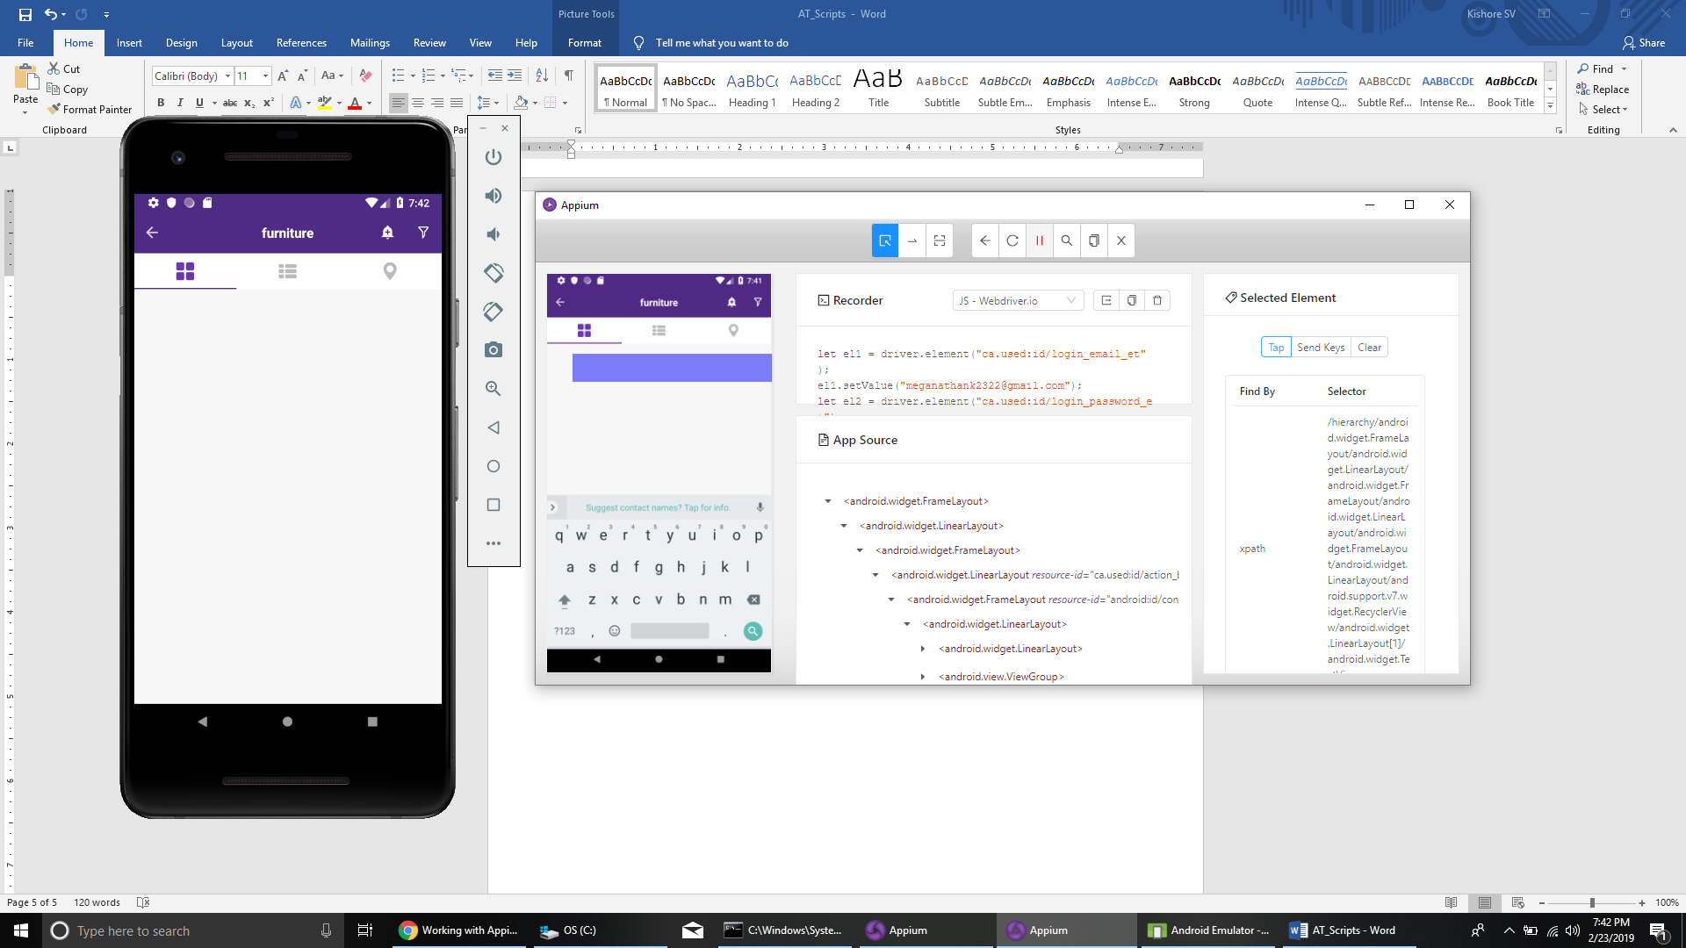

**<DEF_002>-HTTP Error 500 is displayed in Home screen**

**Actual Result:** HTTP Error 500 is displayed in Home screen

**Expected Result:** Home screen should be displayed

**Steps to Reproduce:**

1. Launch the App  
2. Click on Skip Button

